KPI’S

- Total Employees
select COUNT(EmployeeCount) [Total Employees] from dbo.[HR-Employee-Attrition]

output:
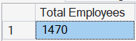

- Attrition Count
select COUNT(Attrition) [Attrition Count] from dbo.[HR-Employee-Attrition]
where Attrition = 1

output:
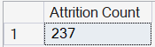

- Attrition Rate
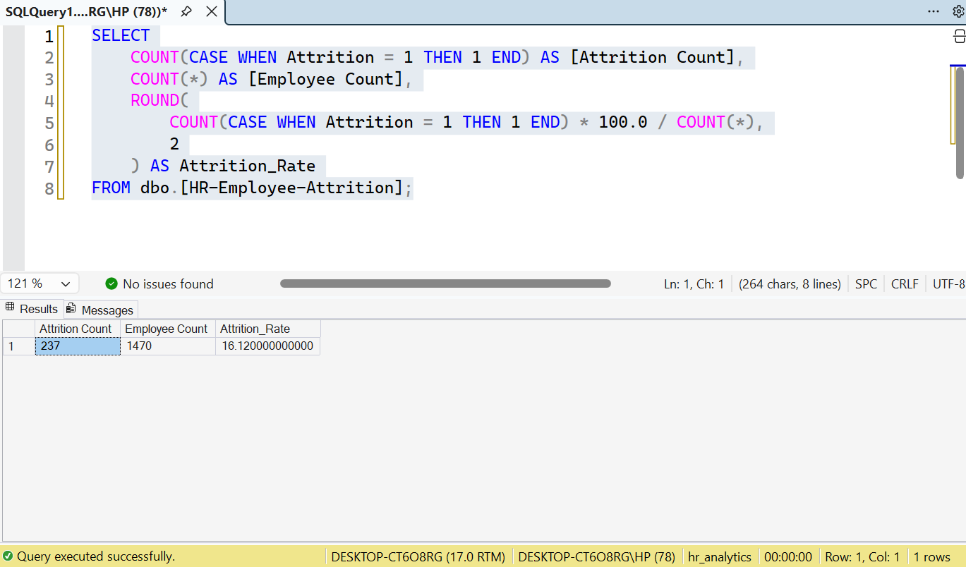

- Avg Monthly Income
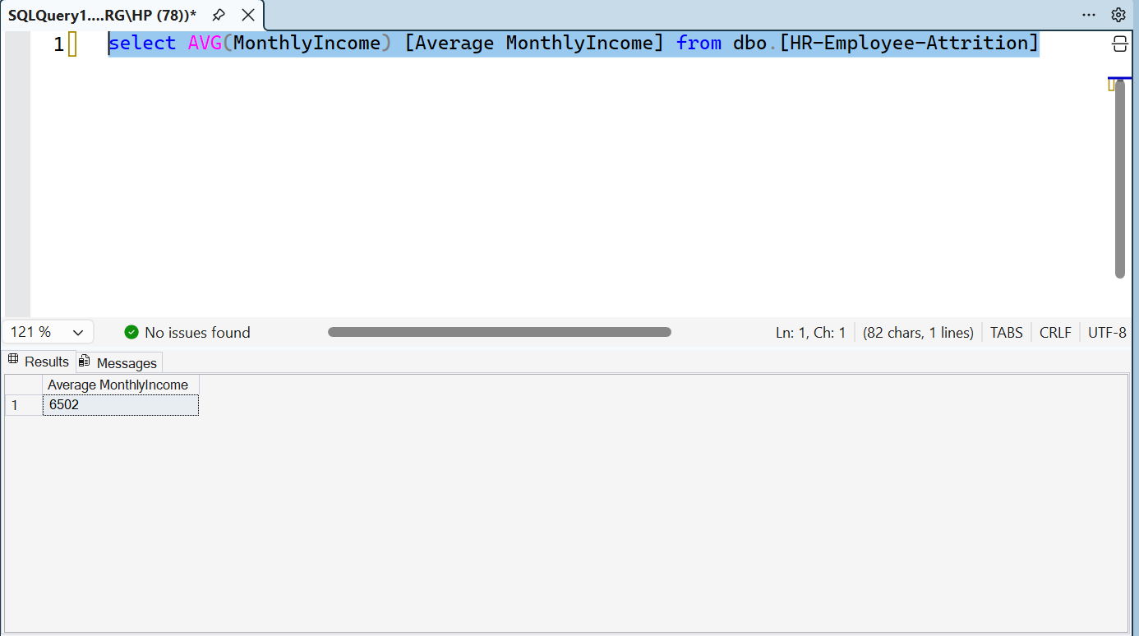

Attriton by Department

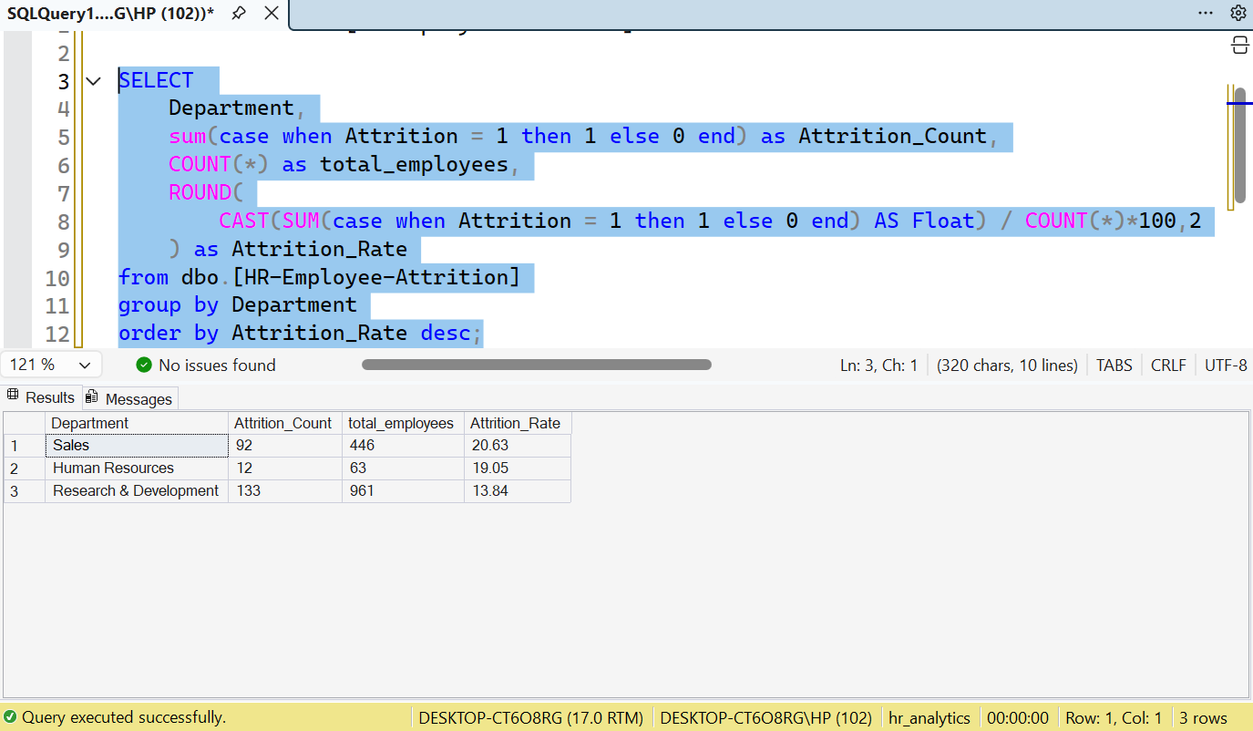

Attrition Based on Overtime
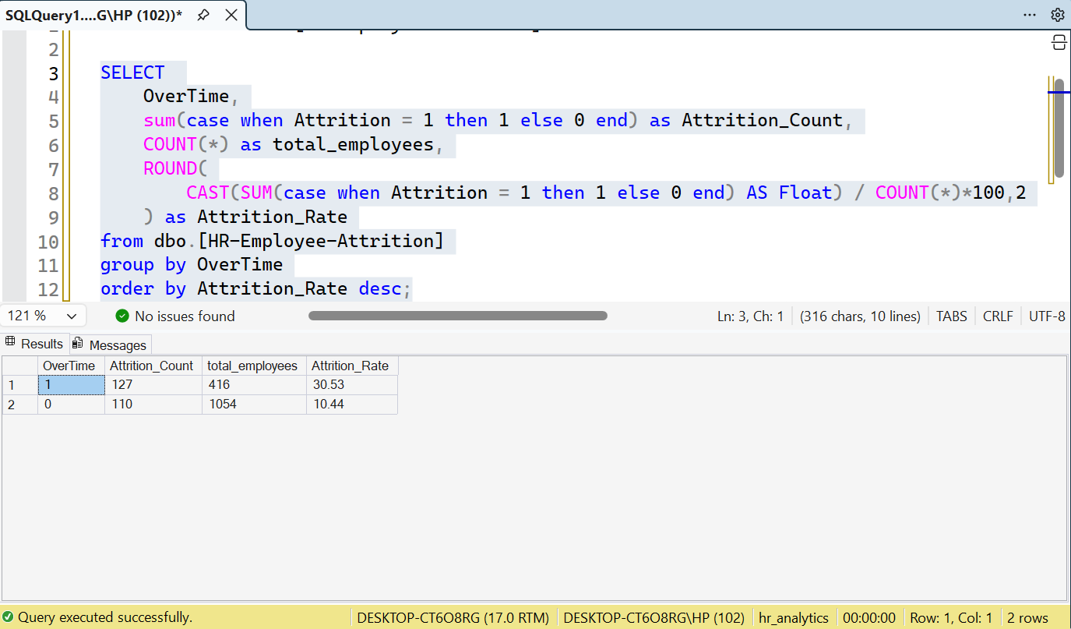

Attrition Based on jobsatisfaction
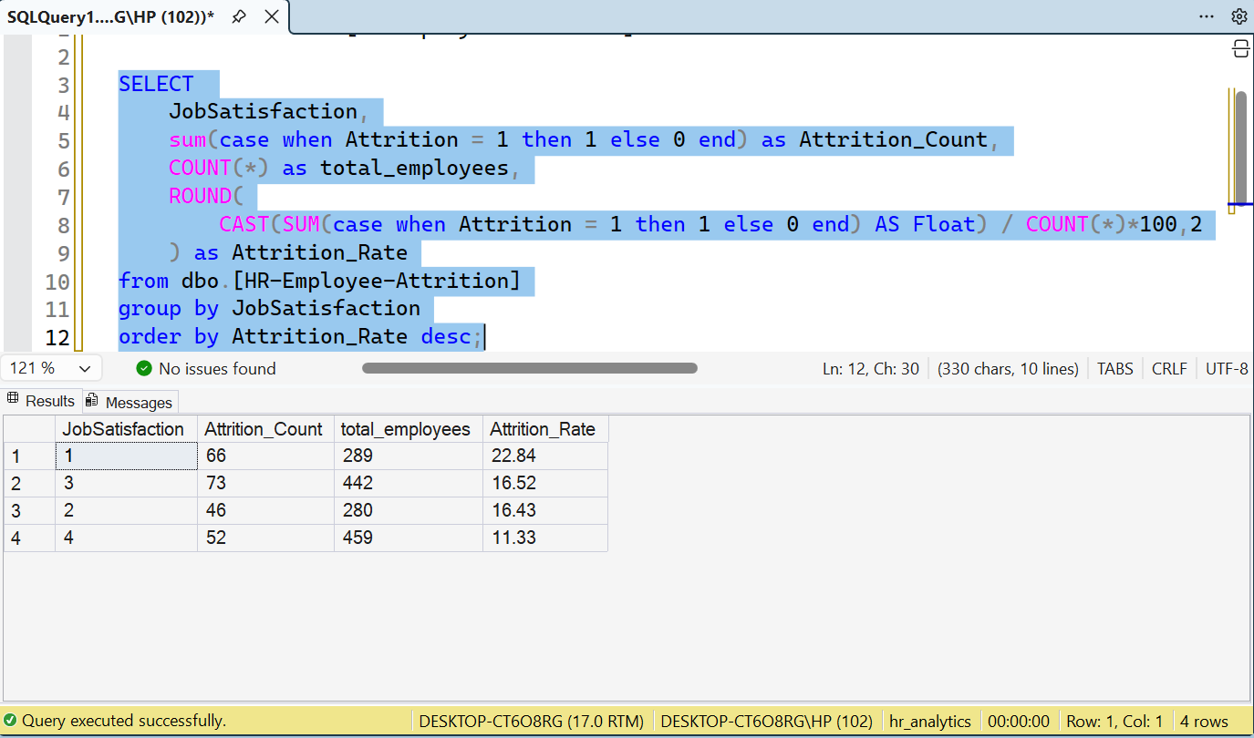

Tenture v/s Attrition
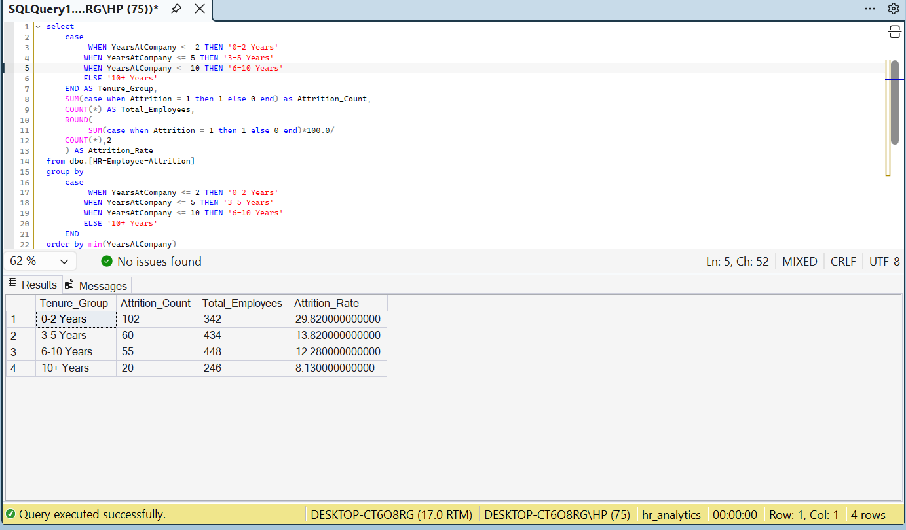

Dasboard

